# Background subtractor performance on stationary background

# Default background subtractor

## Frame count < History

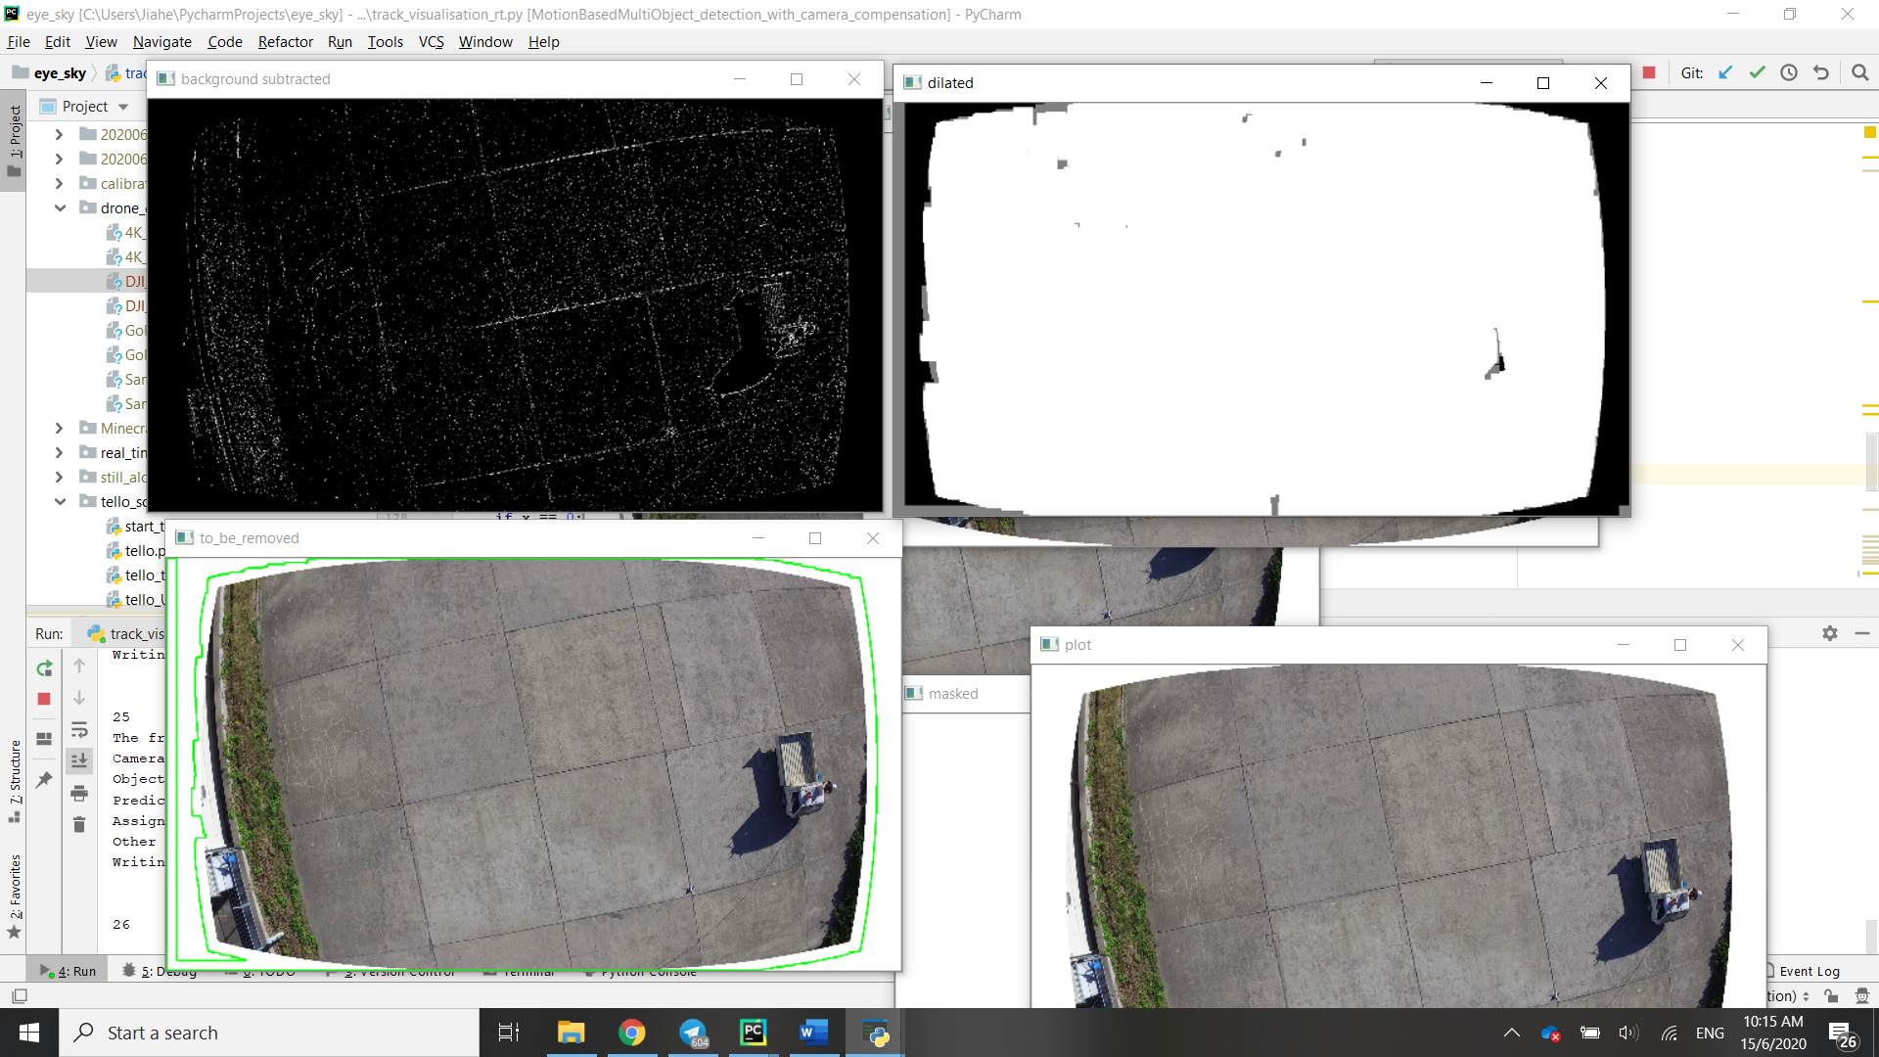

The default background subtractor parameters, with a history of 500, results in a lot of noise. Unless the drone is of a significant size, it will be drowned out by the noise.

 

Attempting to remove the noise by dilation is impossible with this level of noise.

## Frame count > History

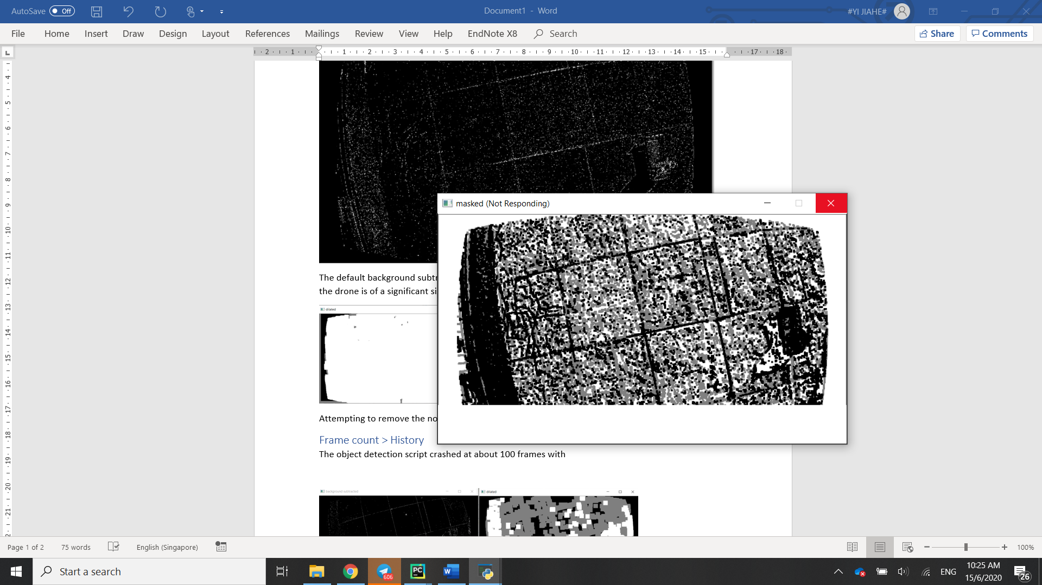

The object detection script crashed at about 100 frames. While I cannot confirm the reason for the crash, I hypothesize the crash was due to a lack of memory, evidenced by this half rendered frame on which the detections were performed. The noisiness of the image likely led to thousands of detections needing to be processed resulting in the image not being fully rendered and the script terminating. This suggests that possibly 500 frames (16 seconds at 30 FPS) to build the history is too long.

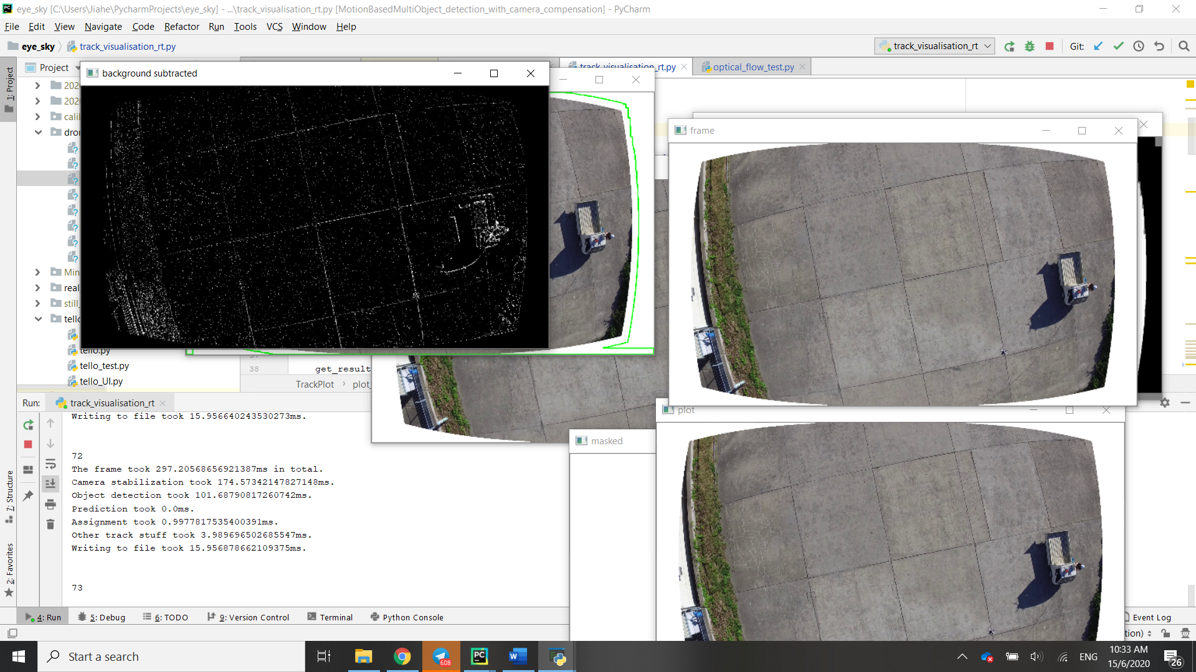

Changing the history to 50 frames, did not help much, with the plotting function (with a timeout of 5 seconds) timing out at 175 frames.

# Adding initial brightness adjustment

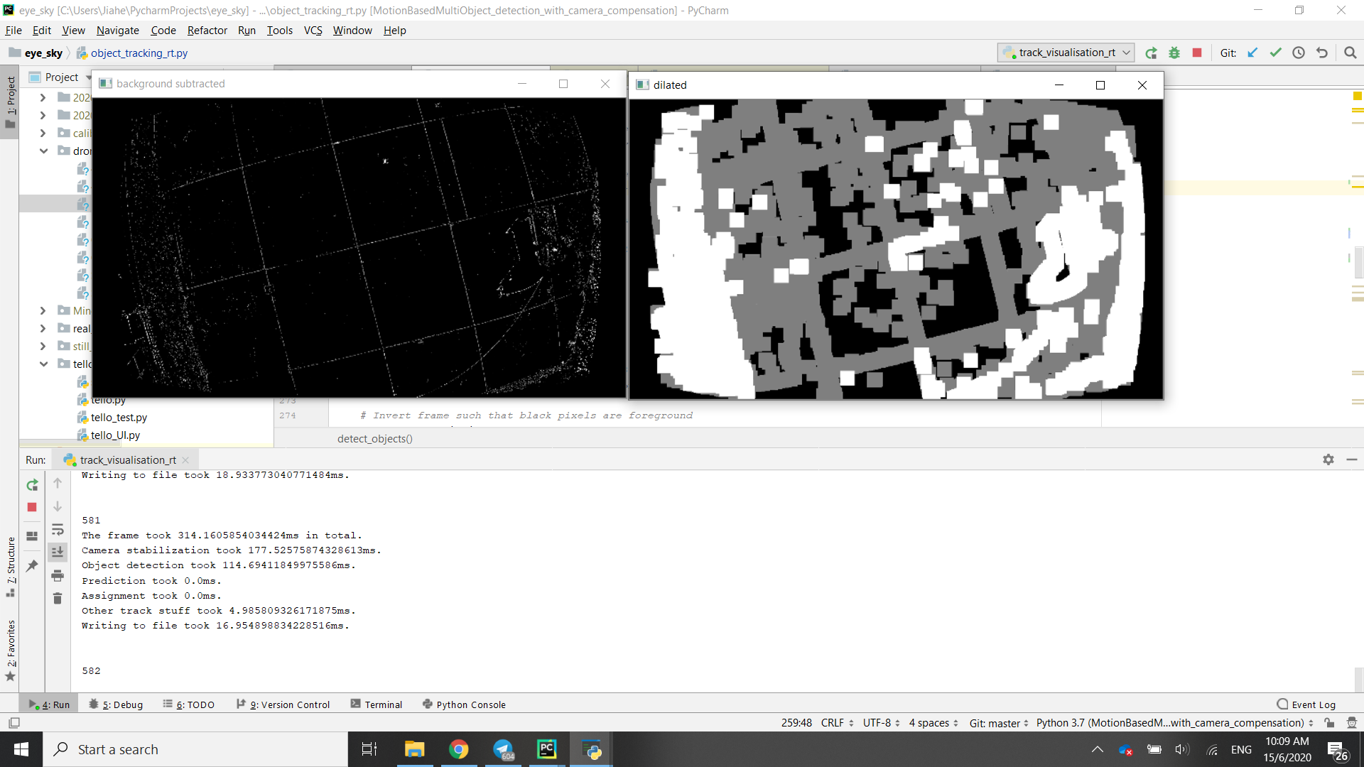

Increasing the brightness beforehand by some function of the average brightness of the frame resulted in less noise, with the foreground mask being generated mainly by distinct features in the image such as outlines.

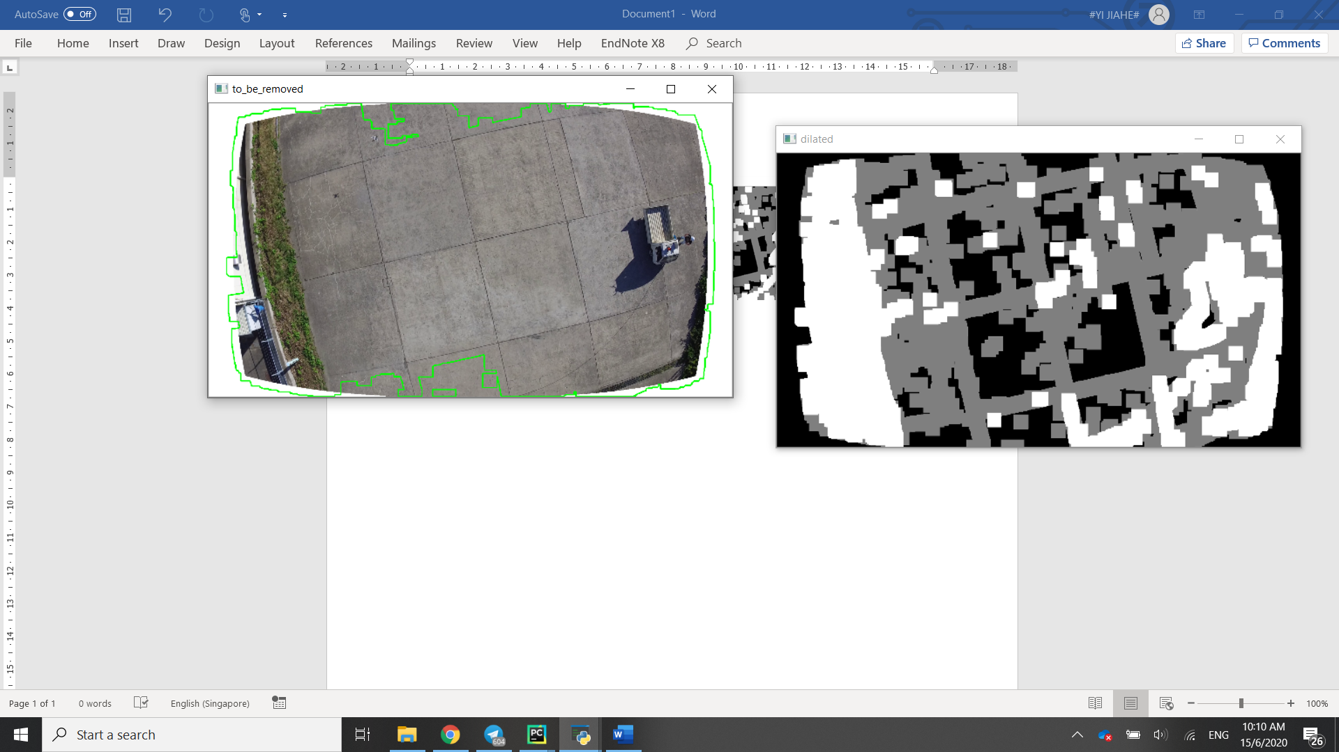

The dilated image shows more clearly the foreground and shadow detections. Again however, there are many more false detections than actual detections. In addition, the shadow mask isn’t providing much useful information.

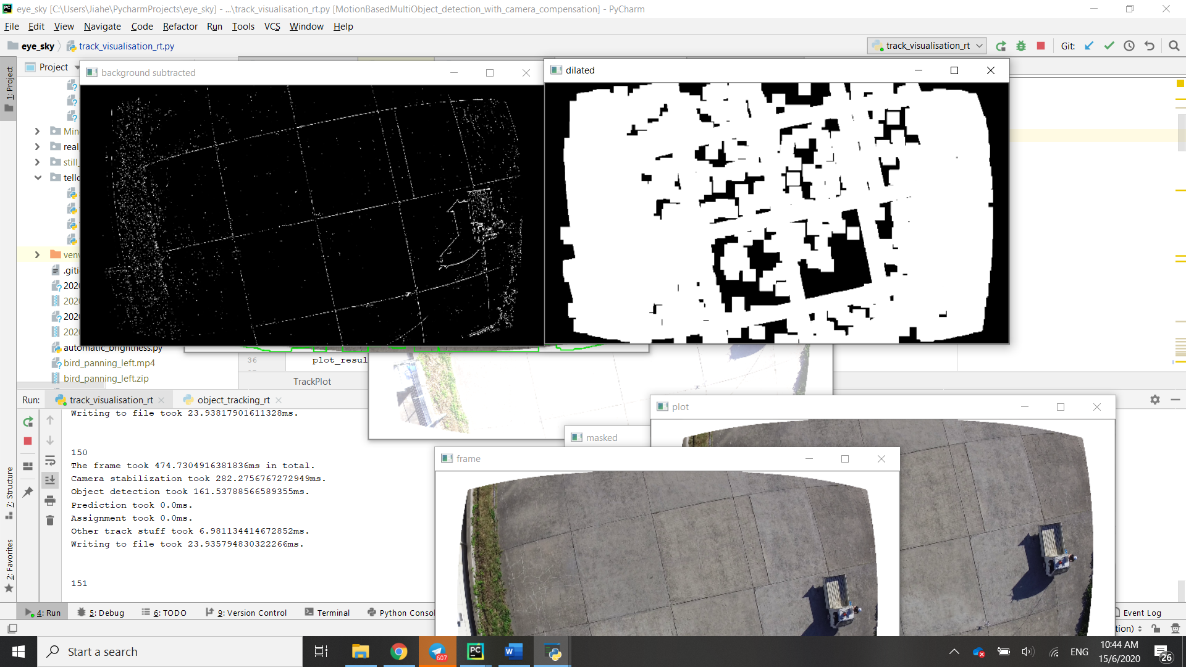

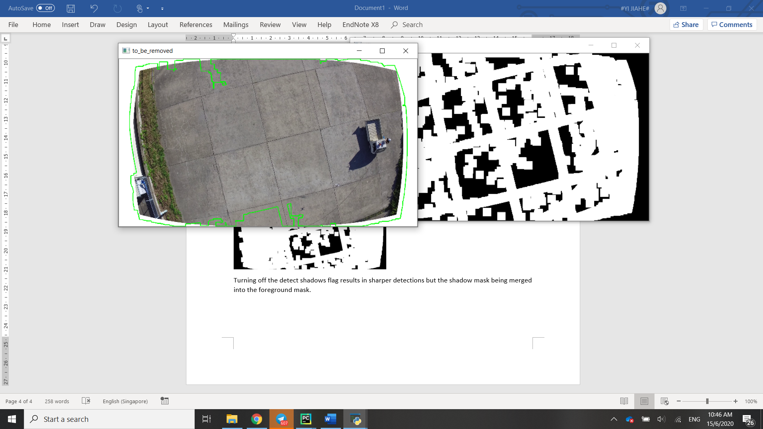

Turning off the detect shadows flag results in sharper detections but the shadow mask being merged into the foreground mask.

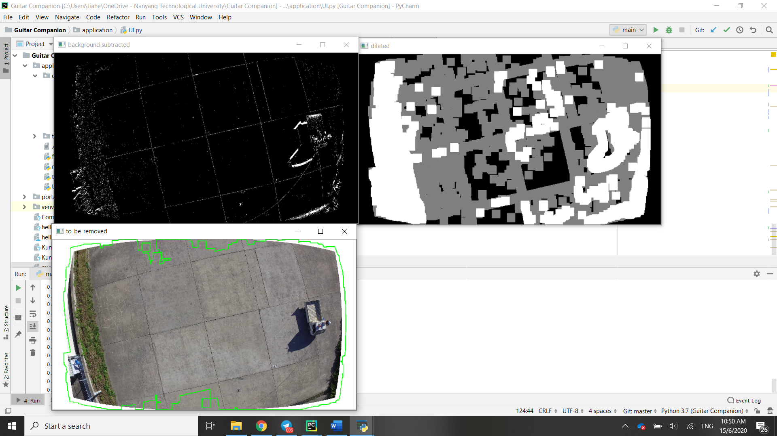

A learning rate of -1, which supposedly results in the algorithm automatically choosing a learning rate does not seem to be any different from a learning rate of 0.

# Current Parameters

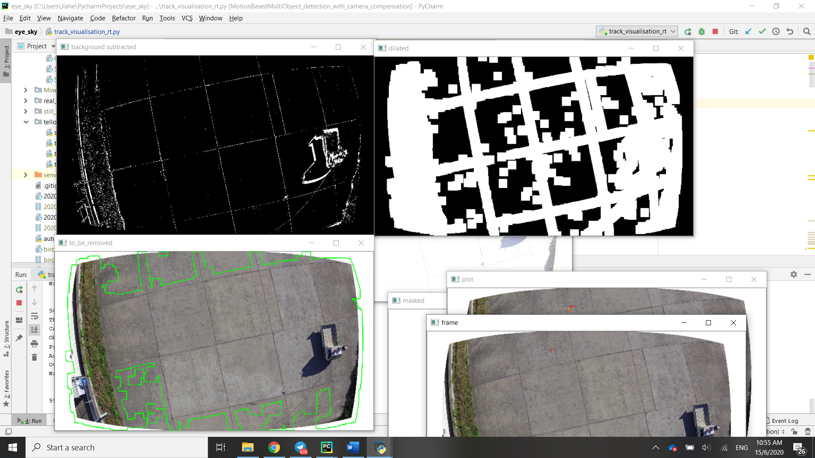

The current parameters, which have worked on drone detection above the horizon, produces less noise, although the image features are far more pronounced.

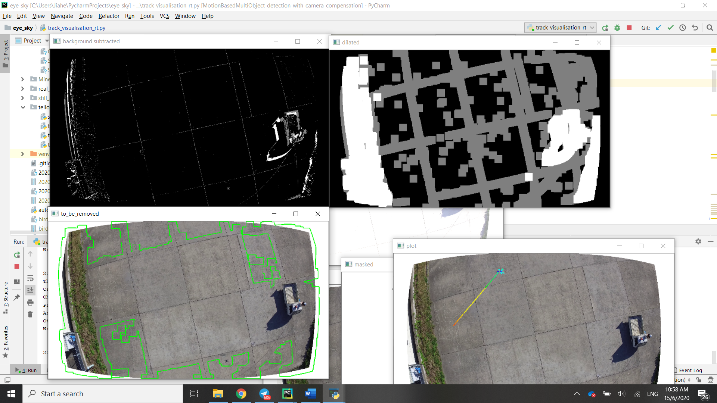



Turning on shadow detection shows that the combination of brightness adjustment and adjusted parameters have (incorrectly) identified the grid on the ground to be shadow, while leaving the actual shadow as foreground. In addition, the drone is also treated as shadow, which means that the distinction between shadow and foreground cannot be exploited to identify the drone.

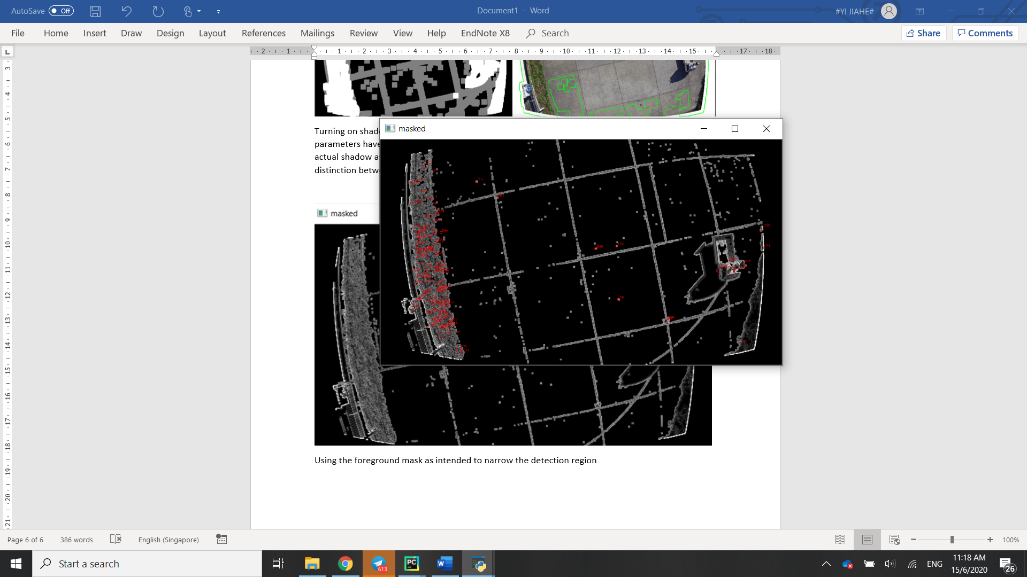

Using the foreground mask as intended to narrow the detection region does not work with the current detection model as it is unable to identify what a drone is, resulting in many false detections again.

# Conclusion

The current model is poorly suited for the case presented, and similar cases where the drone is in front of background objects that cannot be removed by brightness adjustment. Nevertheless, there are some options to take from here.

Firstly, the ground removal algorithm could be adjusted to remove borders made out of distinct features while leaving the insides, such that the inside of the tiles above can still be detected. By predicting the tracks of objects between grids, temporary occlusion could be dealt with. However, this example might be too specific to adjust for and with smaller grid sizes or non-regular objects, this solution might not work.

Secondly, pairing a stationary camera with a stationary background could result in better background subtraction performance. However, in doing so, one would lose the advantages brought about by the current background subtraction model, i.e. more general performance with non-static backgrounds.

Thirdly, the foreground mask could be combined with a different detection algorithm, such as a trained model. Again however, the drawbacks of such a method are closely tied into the detection algorithm used.

Finally different background subtraction methods could be tested, but the question is how different the results are, in what situations and why.